CN ASSIGNMENT 8

Q1. Configuration and Analysis of BGP Routing
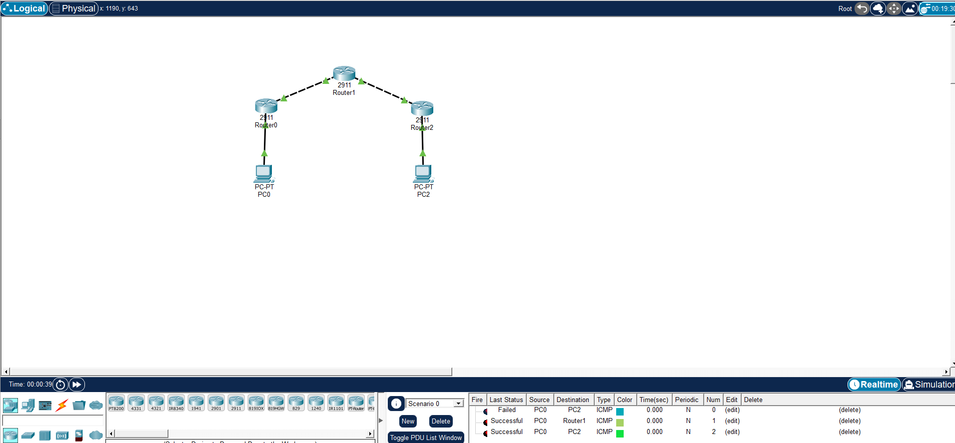

Commands for Router 1:
enable
configure terminal
interface gig0/0/0
ip address 192.168.1.1 255.255.255.0
no shutdown
interface gig0/0/1
ip address 10.0.0.1 255.255.255.252
clock rate 64000
no shutdown
exit
ip route 192.168.2.0 255.255.255.0 10.0.0.2
end
router bgp 100
neighbor 10.0.0.2 remote-as 200
network 192.168.1.0 mask 255.255.255.0
Commands for Router 2:
enable
configure terminal
interface gig0/0/0
ip address 10.0.0.2 255.255.255.252
no shutdown
interface gig0/0/1
ip address 10.0.0.5 255.255.255.252
clock rate 64000
no shutdown

exit
ip route 192.168.1.0 255.255.255.0 10.0.0.1
ip route 192.168.2.0 255.255.255.0 10.0.0.6
end
router bgp 200
neighbor 10.0.0.1 remote-as 100
neighbor 10.0.0.6 remote-as 300
network 10.0.0.0 mask 255.255.255.252
Commands for Router 3:
enable
configure terminal
interface gig0/0/1
ip address 10.0.0.6 255.255.255.252
no shutdown
interface gig0/0/0
ip address 192.168.2.1 255.255.255.0
no shutdown
exit
ip route 192.168.1.0 255.255.255.0 10.0.0.5
end
router bgp 300
neighbor 10.0.0.5 remote-as 200
network 192.168.3.0 mask 255.255.255.0

